**Gaussian Kernel**

The Gaussian kernel is defined as:

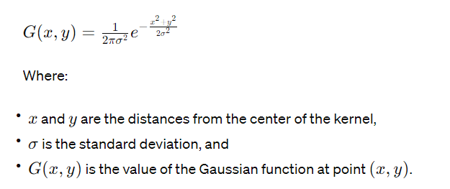

Table-1: 5x5 Gaussian Kernel table

|  |  |
| --- | --- |
| **Kernel** | **Formatted Kernel** |
| [0.00291502 0.01306423 0.02153928 0.01306423 0.00291502]  [0.01306423 0.05854983 0.09653235 0.05854983 0.01306423]  [0.02153928 0.09653235 0.15915494 0.09653235 0.02153928]  [0.01306423 0.05854983 0.09653235 0.05854983 0.01306423]  [0.00291502 0.01306423 0.02153928 0.01306423 0.00291502] | [[ 1 4 7 4 1]  [ 4 20 33 20 4]  [ 7 33 54 33 7]  [ 4 20 33 20 4]  [ 1 4 7 4 1]] |

**Practical Experiment:**

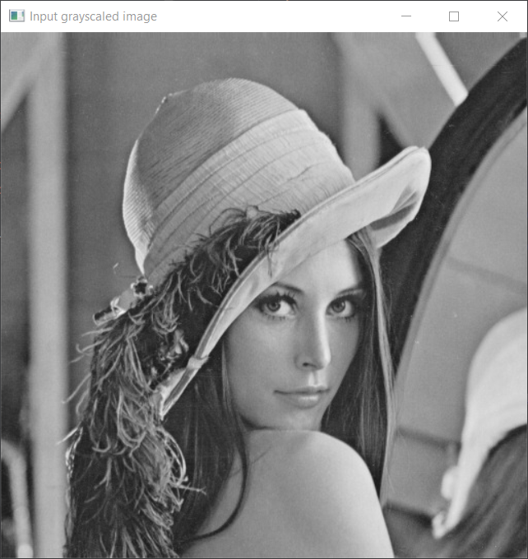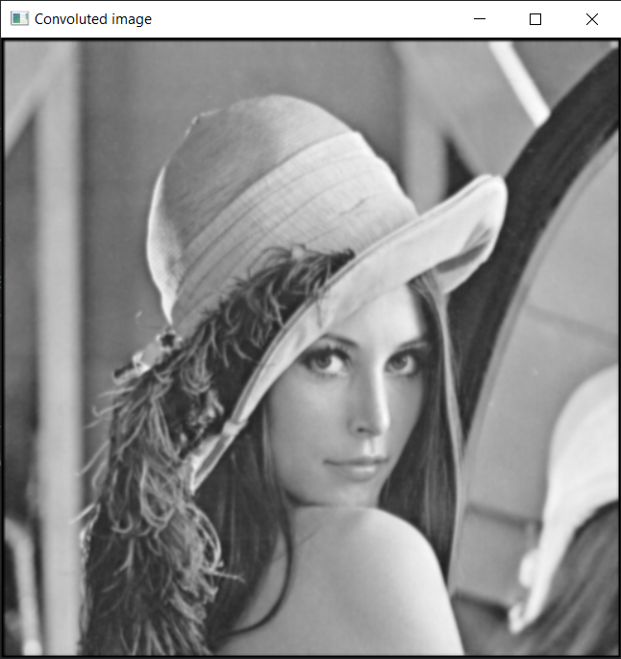

Fig-1: Input grayscaled image and output convoluted image(gaussian)

**Mean Kernel**

Mathematically, the mean kernel is defined as a matrix of equal weights:

Table-2: 3x3 Mean Kernel Table

|  |  |
| --- | --- |
| **Kernel** | **Formatted Kernel** |
| [0.11111111 0.11111111 0.11111111]  [0.11111111 0.11111111 0.11111111]  [0.11111111 0.11111111 0.11111111] | [1. 1. 1.]  [1. 1. 1.]  [1. 1. 1.] |

**Practical Experiment:**

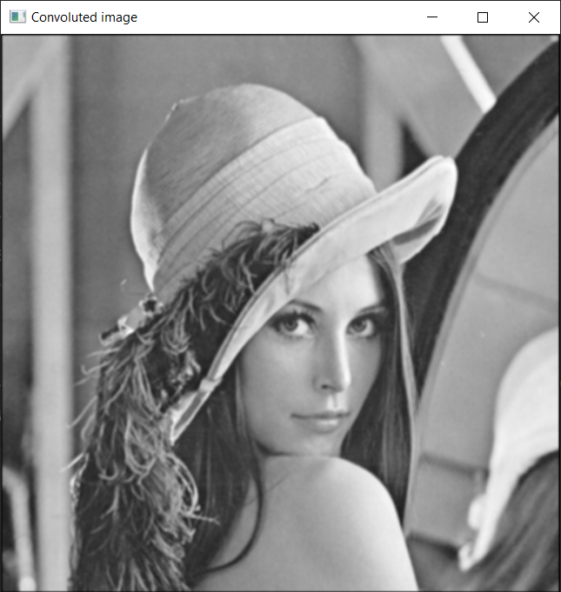

Fig-2: Input grayscaled image and output convoluted image(mean)

**Laplacian kernel**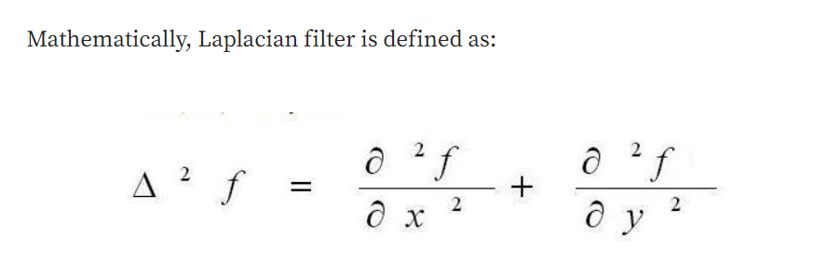

Table-3: 3x3 Center positive Laplacian kernel Table

|  |  |
| --- | --- |
| **Kernel** | **Formatted Kernel** |
| [[-1 -1 -1]  [-1 8 -1]  [-1 -1 -1]] | [[-1 -1 -1]  [-1 8 -1]  [-1 -1 -1]] |

**Practical Experiment:**

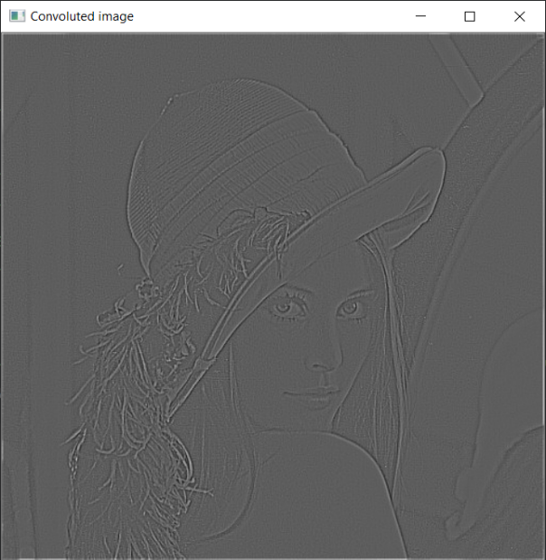

Fig-3: Input grayscaled image and output convoluted image(Laplacian center positive kernel)

Table-4: 3x3 Center negative Laplacian kernel Table

|  |  |
| --- | --- |
| **Kernel** | **Formatted Kernel** |
| [ 1 1 1]  [ 1 -8 1]  [ 1 1 1] | [ 1 1 1]  [ 1 -8 1]  [ 1 1 1] |

**Practical Experiment:**

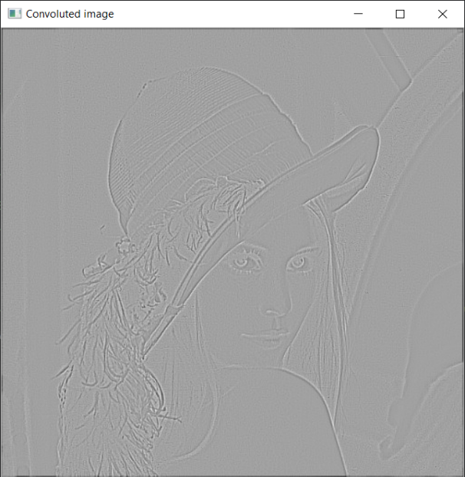

Fig-4: Input grayscaled image and output convoluted image(Laplacian center negative kernel)

**LOG Kernel:**

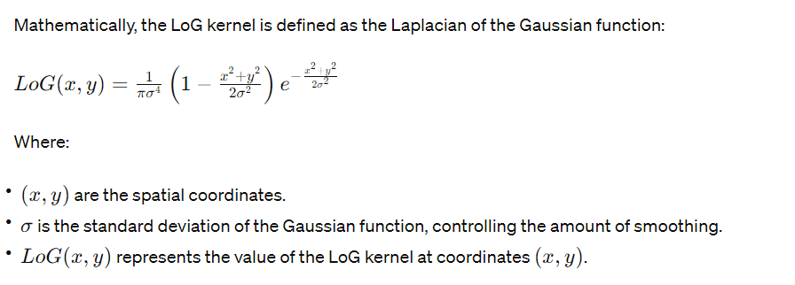

**Practical Experiment:**

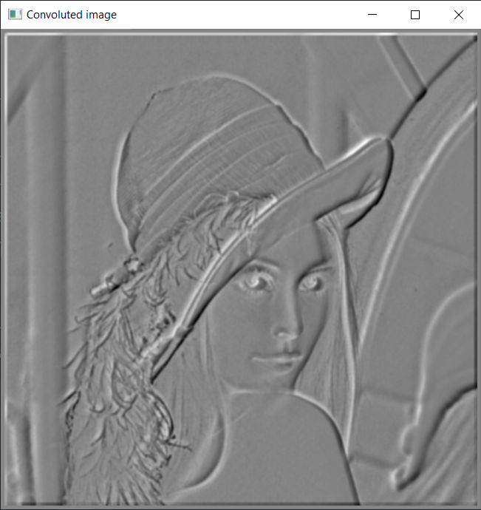

Fig-5: Input grayscaled image and output convoluted image(LoG kernel)

**Sobel kernel**

|  |  |
| --- | --- |
| Horizontal Sobel Kernel | Vertical Sobel kernel |
| |-1 -2 -1 |  | 0 0 0 |  | 1 2 1 | | | -1 0 1 |  | -2 0 2 |  | -1 0 1 | |

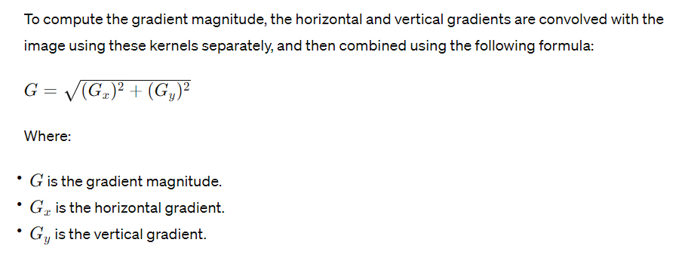

**Practical Experiment:**

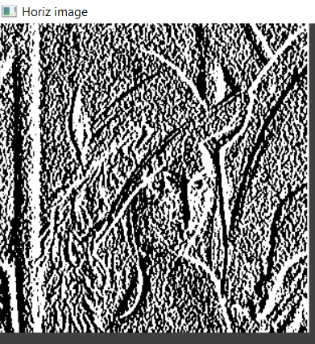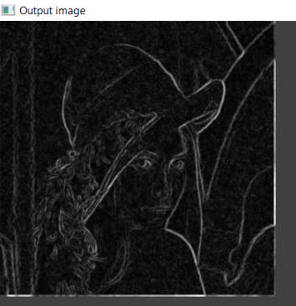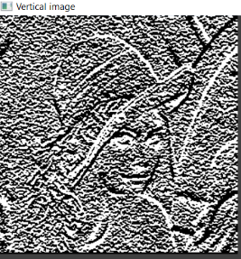

Fig-6: Horizontal, Vertical and output convoluted image(Sobel kernel)

**Operation Type:** HSV & RGB Difference

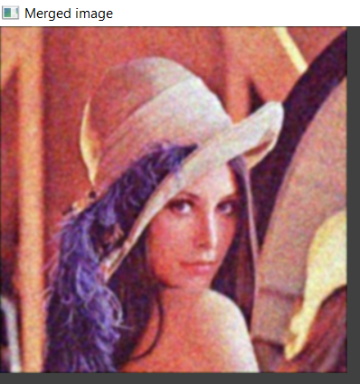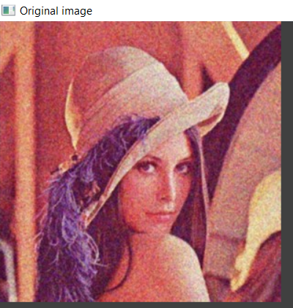

Fig-7: Original RGB image and output convoluted image

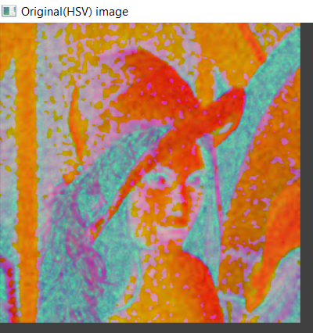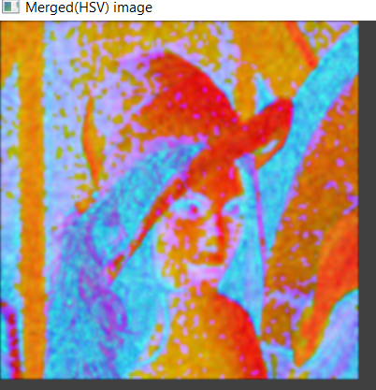

Fig-8: Original RGB image and output convoluted image

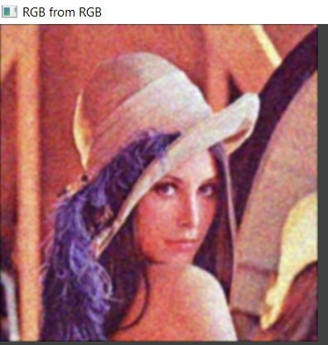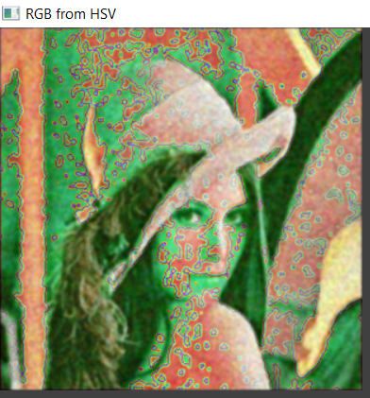

Fig-8: RGB convoluted image and HSV to RGB convoluted image

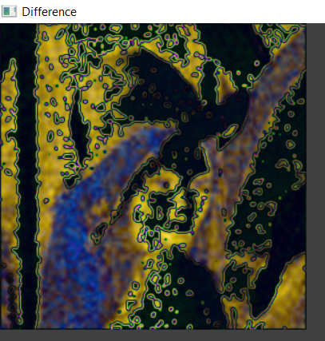

Fig-9: Difference between RGB convoluted image and HSV to RGB convoluted image